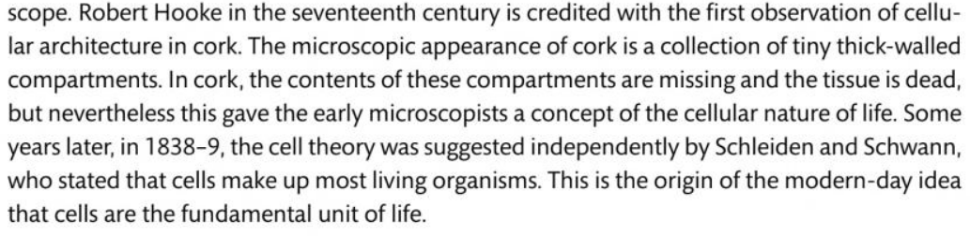

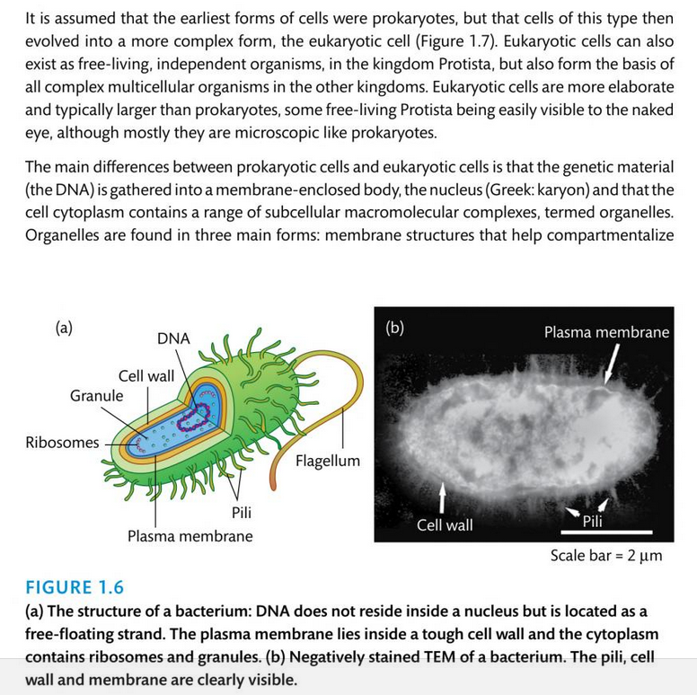

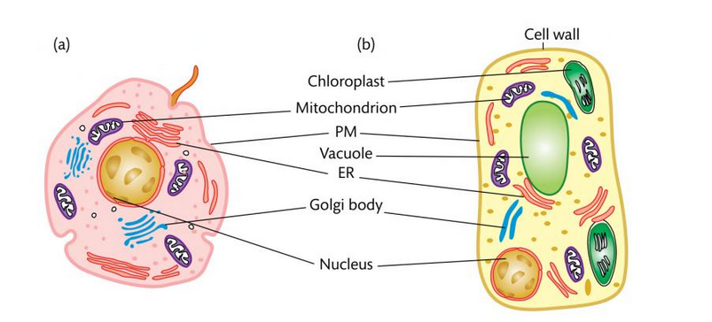

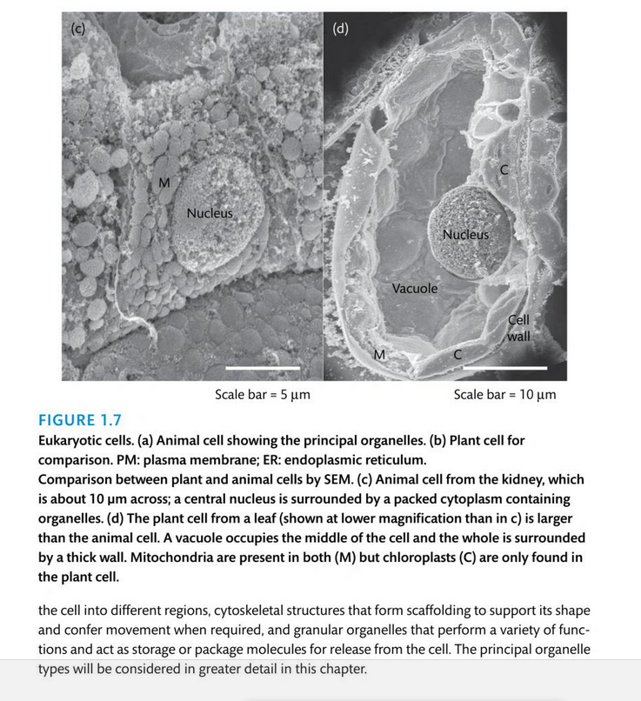

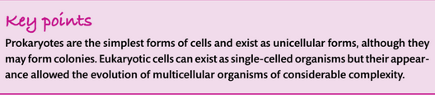

The cell contents are surrounded by a plasma membrane called the plasmalemma and are enclosed by a cell wall. The cell contains organelles, each with its own characteristic shape, which divide the cell into various compartments (sub-cellular compartments). Each compartment has specialized metabolic func-tions, which will be discussed in detail in the following chapters (see alsoTable 1.1). The largest organelle, the vacuole, usually fills about 80% of the total cell volume. Chloroplasts represent the next largest compartment, and the rest of the cell volume is filled with mitochondria, peroxisomes, the nucleus, the endoplasmic reticulum, the Golgi bodies, and, outside these organelles, the cell plasma, called cytosol. In addition, there are oil bodies derived from the endoplasmic reticulum. These oil bodies, which occur in seeds and some other tissues (e.g., root nodules), are storage organelles for triglycerides (see Chapter 15 The nucleus is surrounded by the nuclear envelope, which consists of the two membranes of the endoplasmic reticulum. The space between the two membranes is known as the perinuclear space. The nuclear envelope is inter- rupted by nuclear pores with a diameter of about 50 nm. The nucleus con-tains chromatin, consisting of DNA double strands that are stabilized by being bound to basic proteins (histones). The genes of the nucleus are collectively referred to as the nuclear genome. Within the nucleus, usually off-center, lies the nucleolus, where ribosomal subunits are formed. These ribosomal subunits and the messenger RNA formed by transcription of the DNA in the nucleus migrate through the nuclear pores to the ribosomes in the cytosol, the site of protein biosynthesis. The synthesized proteins are distributed between the different cell compartments according to their final destination.

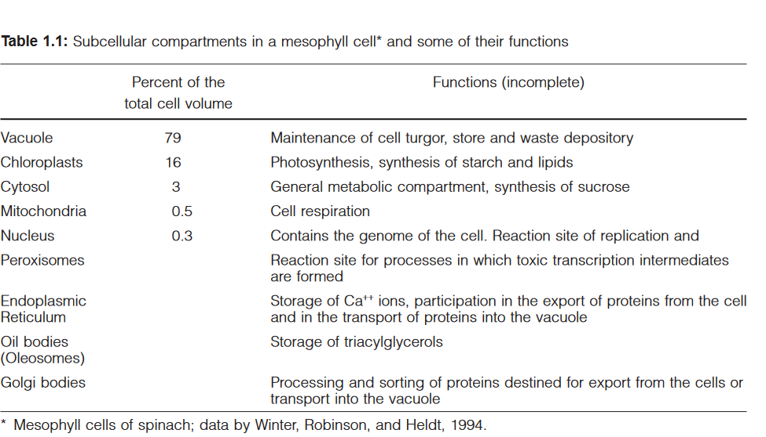

American Ecologist Whittaker (1969) proposed the five kingdom system of classification. In his'Five Kingdom System', he added three more kingdoms in Linnean model of two kingdom system.

Whittaker's five kingdom system of classification is based on (a) mode of nutrition (b) cell structure and complexity (c) phylogenetic relationship (d) body organization and (e) reproduction.

In five kingdom system of Whittaker, different kingdoms are as following:

1. **Monera** : Prokaryotes e.g. bacteria and cyanobacteria.

2. **Protista** : Unicellular eukaryotes e.g.unicellular algae, diatoms, and protozoan.

3. **Fungi :** Multicellular decomposers e.g. fungi and moulds.

4. **Plantae** : Multicellular producers, e.g. plants.

5. **Animalia** : Multicellular consumers, e.g. animals.

|  |
| --- |
| The term Protista was first used by Ernst Haeckel in 1866. Protists were traditionally subdivided into several groups based on similarities to the "higher" kingdoms such as:[6]  -1**Protozoa**  Protozoans are unicellular "animal-like" (heterotrophic, and sometimes parasitic) organisms that are further sub-divided based on characteristics such as motility, such as the (flagellated) Flagellata, the (ciliated) Ciliophora, the (phagocytic) amoeba, and the (spore-forming) Sporozoa.  -2**Protophyta**  Protophyta are "plant-like" (autotrophic) organisms that are composed mostly of unicellular algae. The dinoflagellates, diatoms and Euglena-like flagellates are photosynthetic protists.  -3**Mold**  Molds generally refer to fungi; but slime molds and water molds are "fungus-like" (saprophytic) protists, although some are pathogens. |

Monera are prokaryotic and virtually unicellular, they differ from the other four eukaryotic kingdoms. The eukaryotic unicellular organisms were kept into the Kingdom Protista. The unicellular organisms show several types of modes of nutrition. The three multicellular eukaryotic kingdoms distinguish themselves by the general manner in which they acquire food. Fungi are heterotrophs, generally break down large organic molecules in their environment by secreting enzymes. Plants are autotrophs and use photosynthetic systems to capture energy from sunlight. Animals are heterotrophs and acquire nutrients by ingesting plants or other animals and then digesting those materials. The five kingdom system despite of having some demerits (Verma, 2016a), is still widely accepted.

An American Microbiologist, Woese et al., (1990) adopted the term 'domain' in 1990 and introduced three-domain system in biological classification mainly on the basis of 16 S rRNA genes. They defined the Archea by studying 16 S ribosomal RNA in phylogenetic taxonomy. This system adds'domain' as a 'superkingdom' a level of classification “above” the kingdom. The three domains are: Archaea, Bacteria and Eukarya (Eucarya). The domain Archaea includes only one kingdom Archaebacteria (ancient bacteria), domain Bacteria also includes only one kingdom Eubacteria (true bacteria) whereas domain Eukarya includes remaining four kingdoms namely Protista, Fungi, Plantae and Animalia. The Archaea and Bacteria domains contain prokaryotic organisms that do not have a membrane bound nucleus while the Eukarya domain includes eukaryotic organisms that have a membrane bound nucleus. Thus, in this classification system, Woese et al., (1990) placed all four eukaryotic kingdoms into a single domain called Eukarya (eukaryotes). They then split the former kingdom of Monera into the Archaea (archaebacteria) and the Bacteria (eubacteria) domains. They appropriately placed most of the'unusual' prokaryotes in the Archaea, leaving traditional bacteria in the Eubacteria. This is consistent with recent discoveries of more diversity among microbes than animals and plants that makes this system relevant (Verma, 2016b). A comparison between the five and six kingdom systems is given by Verma (2017a).

**Archaebacteria and Bacteria**

The members of the Archaea and Bacteria are united in the“realm of prokaryotes” by similar general cell sizes, the lack of a nuclear membrane and organelles, and the presence of a large circular chromosome occasionally accompanied by one or more smaller circular DNA plasmids.

